Engineering a Better Paper Airplane
Can I refine a Paper Airplane Design
to Fly Farther?

Marc Matos
Ms. O’Grady
November 17, 2015
Table of Contents

Table of Contents 2
Introduction 3
Problem/Question/Hypothesis 4
Research
Background Information 5
Definitions 7
Mathematical Concepts 7
Materials 8
Procedures 9
Data
Qualitative Observations 11
Quantitative Observations 16
Charts 19
Results 21
Conclusion 24
Acknowledgements 26
Bibliography 27

Introduction
________________________________
Which Paper Airplane Design Flies the Furthest?
Does Paper Type Effect Flight Distance?
________________________________

My brother and I sometimes throw paper airplanes at each other when we are playing. I wanted to be able to hit him from farther away and not have him hit me. I noticed that different designs of planes flew father than others, so I began to wonder if any modifications to the planes could make them fly farther. Also, it would be great to win paper airplane throwing competitions!
I will investigate which paper airplane design flies the farthest. Taking the best designs, I will then determine if different paper types effect flight distance. The winning design and paper type will then be revised by adding wing flaps, winglets and additional weight (paperclips) to hopefully increase flight distance.
The optimized paper airplane distance contests.

Problem:
To investigate which paper airplane design flies the farthest and then determine if different paper types effect flight distance. The winning design and paper type will be revised by adding wing flaps, winglets, additional weight (paperclips), etc. to increase flight distance. The planes can be optimized for paper airplane distance contests.

Question:
Which paper airplane design flies the farthest and what effect will modifications in materials and design have on flight distance?

Hypothesis:
I think that the bullet plane made of copy paper will go the farthest. I believe the addition of a paperclip (weight) to the front will increase distance.

Research - Background Information:
What paper airplane design flies the farthest? I think the bullet paper plane made of copy paper with a paperclip on the front will go the farthest. Will paper type effect flight? I think heavier paper (cardstock) will have too much weight to create the lift necessary for a good flight. The notebook paper will be too light and flimsy for larger winged planes. It also has holes which may affect the flight distance.

Hand Thrown Paper Airplanes
I know that paper airplane flight changes based on paper type/weight, design, speed thrown, little things like winglets, wing flaps, weight (paper-clips), etc. I knew that when a paper airplane is thrown by hand the speed is not consistent, so I thought about how to make launching planes consistently. Then, I thought about using an airplane launcher to launch the planes consistently. For the measurements I thought it would be easiest to measure the distance in feet and inches and then turn it into an average in feet. I did find similar experiments on Sciencebuddies.com.

During the researching I found a few words that I didn’t know the meaning of (aerodynamics, stall, and dihedral). When I looked up the definition of the words I found out aerodynamics is the study of how air flows around a solid object. Stall is when a plane loses lift. I also found out dihedral is when the wings are angled upward slightly. Some tools I used (with a little help) were soldering iron, wire cutter/striper, measuring laser, power screwdriver, and the airplane launcher.

Motorized Paper Airplane Launcher
I thought that throwing the planes by hand would have too much variability, so I thought about making an airplane launcher which would have the same consistence the whole time. The basic design was based on an idea found on instructables.com for a “super-fast paper airplane launcher”. The launcher was built by putting 2 D.C. motors on a long piece of wood with two other pieces of wood screwed on top to create a channel for the planes to be guided through. Two rubber tires on plastic wheels were attached to the motors to launch the plane forward. 3 AA batteries (4.5 Volts) were used to power the motors.

During the initial testing of the launcher it was found that the thicker paper would jam the tires/wheels. The original launcher design was changed to allow for thicker planes to go through the wheels. Unfortunately after 20 flights the launcher fell apart and the experiments had to be repeated by hand throwing the planes. Since the Motorized Paper Airplane Launcher was built and some data was collected, it is included in the logbook (possibly to compare with the hand thrown planes in the future).

My hypothesis is “I think the bullet plane made of copy paper with a paperclip on the front will go the farthest.”

Definitions
Aerodynamics – the study of how air flows around a solid object (like an airplane)
Dihedral – wings slightly angled upward
Drag - the backward force resisting the forward motion of an airplane when flying through the air causing it to slow down
Lift - the force that is upward perpendicular when a wing flies through the air
Nose/Tip – the front of the airplane
Stall – when a plane loses lift
Wing – the horizontal surface that provides lift for an airplane
Wing Flap/Elevator - devices used to alter the lift characteristics of a wing and are mounted on the trailing edges (small tabs on the back edge of a paper airplane wing)
Winglet/Wingtip Device – a small vertical wing on the end of a normal wing reduces drag

Mathematical Concepts/Equations Used
% Change = $\frac{(Flight Distance for Variant-Flight Distance for Original)}{Flight Distance for Original}x 100$
Mean - The mean is found by adding up all the data values and dividing by the number of data values. In this experiment the 2 shortest flights were not used to account for misthrows.
Median: The median of a data set is the middle value when the data values are arranged in order. In the case of 3 data values it is the value with one value higher and one value lower.

Materials:
Paper Airplane Launcher
3 pieces of wood, 2 5 volt DC motors, batteries, wire and connectors, rubber tires on plastic wheels, tape, screws

Paper Airplanes
10 airplane designs, construction paper, 20# copy paper, 110# cardstock paper, notebook paper, tape

Other
Laser distance measure – to quickly and accurately measure the distance flown

Procedures:
- Select 10 paper airplane designs with varying wing types and profiles.

- Make a paper airplane launcher based on a design from instructibles.com.

- Then make 10 planes out of 20# copy paper.

- Test each plane with 5 flights and average out the 3 best.

  - Used Launcher to create consistent launching.

    - 10 planes launched

    - Distance measured using Laser Distance Measurer

    - Repeat i. and ii.

  - Launcher failed after first 20 tests.

- Entire Tests redone throwing by hand (Test each plane with 5 flights and average out the 3 best flights).
  - Sit in a chair in a fixed location.

  - Throw the planes in the same manner each time.

  - Randomly mix up the order of the planes to help offset any bias.

  - Use laser distance measurer to measure distance.

  - Repeat a. through d.

- The top 3 planes were remade using different paper with different characteristics, such as paper weight and smoothness.
  - Construction paper

  - Notebook paper

  - Cardstock (110# Georgia-Pacific)

  - Copy Paper (reused the planes from the initial testing)

- Once the top distance winner is determined (plane and paper type) revise that design by adding wing flaps, winglets, additional weight (paperclips), etc.

- Repeat flight testing (Step 5) 5 times for each variant.

- Determine which variants flew farthest.

- Combined best two variants.

- Repeat Flight testing (Step 5) for these planes.

- Conduct any additional variant combinations data for comparison.

Data
Qualitative Observations:
Plane | Observations
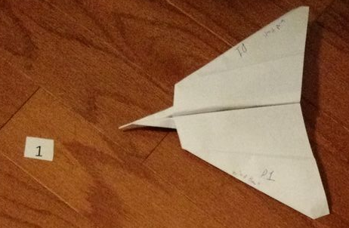 | Plane 1: Wind Hawk  Triangular wings, point nose, larger than average wings  Flight: spiraled a lot.
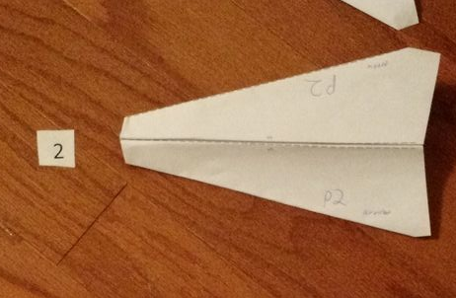 | Plane 2: Arrow  Triangular wings, flat front, larger than average wings,  Flight: flew consistently well.
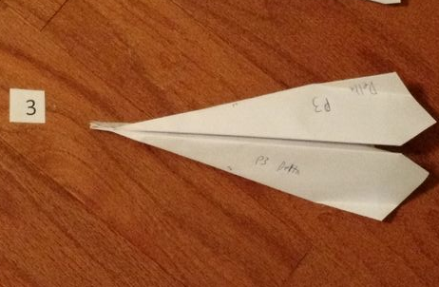 | Plane 3: Delta  Pointy-ish tip, 2 triangles pointing backward (may be similar to flaps?)  Flight: flew well – very well with mechanical launcher
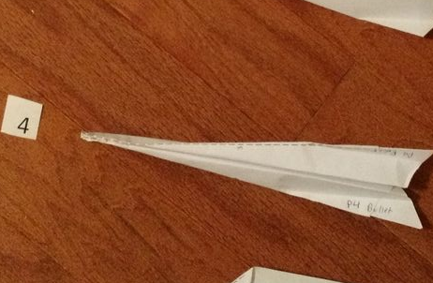 | Plane 4: Bullet  Very small wings, looks like a dart, small winglets (not very tall)  Flight: flew well – very well with mechanical launcher
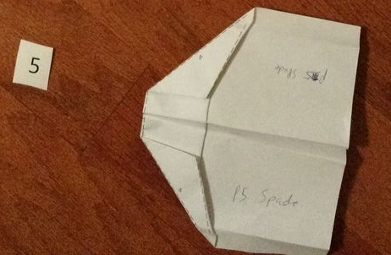 | Plane 5: Spade  Very big, square (a lot of surface area), same front as Plane 2  Flight: Hand thrown - flew like a hang glider
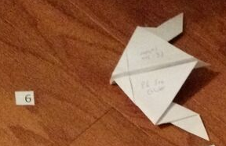 | Plane 6: Sea Glider  Very small nose, odd wings,  Flight: flew very poorly. Very sharp turns to the right and flips.

Plane | Observations
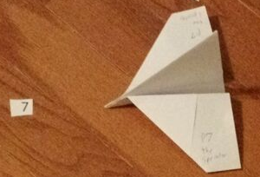 | Plane 7: Sprinter  Large Tail and large wings,  Flight: either flew very well or nose-dived. Very sensitive throw.
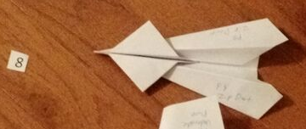 | Plane 8: Zip Dart  Small front wings and back wings like Plane 3.  Flight: Flew very well (won) with the Launcher. Finished 4th when Hand Thrown.
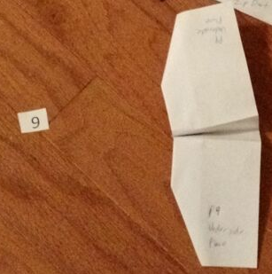 | Plane 9: Underside  Huge wings that kind of fluttered. No real tip.  Flight: Flew poorly with Launcher, flew much better when Hand Thrown
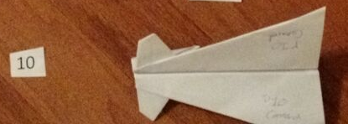 | Plane 10: Canard  Has stabilizers on the front and triangular wings  Flight: flew poorly by launcher, flew well by hand throw,

Mechanical launcher either made planes fly very well or very poorly. Most planes seem to be effected (either positively or negatively) by the amount of force they are thrown with.

Paper Type Observations
Paper Type | Observations
Cardstock | Harder to fold, very hard to fold multiple times, much heavier, very stiff  Flight: made most Plane 7 dive
Notebook | Lightest, holes in the paper, very flimsy  Flight: made Plane 7 spiral uncontrollably
Construction | Thick but flimsy, tears easy, started falling apart after multiple folds  Flight: made Plane 7 dive sharply
Copy | Good paper. Folded well, was thick, but not very thick. Held it’s shape well.  Flight: consistent in all plane designs.

Design Modification Observations
Modification | Observations
Winglets - up | Reduced distance flown a little because of slight stall at end.
Winglets - down | Increased distance flown, looked like it glided better. Floated.
Flaps - up | Reduced distance flown significantly. Stalled and dove quickly.
Flaps - down | Decreased distance flown slightly.
Weight added - front | Fast descent causing it to slide across floor. Distance flown increased.
Weight added - middle | Flew same way, but flew further.
Weight added - back | Glides better and increased distance.

Combined Design Modification - Observations
Modifications | Observations
Winglets & Flaps | Combined caused fast stalls and loops.
Winglets & Weight Front | Nothing notable.
Winglets & Weight Middle | Good flight – glided well.
Winglets & Weight Back | Either was a good flight or stalled and came back toward thrower.
Flaps &  Weight Front | No real effects on flight from just flaps
Flaps &  Weight Middle | No real effects on flight from just flaps, but slid further on ground.
Flaps &  Weight Back | No real effect from just flaps

When Winglets and Flaps were combined with Weight changes, only Winglets Up – Flaps Down – Weight Middle made the plane fly better. All other combinations had bad stalls and/or loops. Some even had backwards distance.
Quantitative Observations:
Test Flights 11/7/2015 3:45 - 4:20 pm
Planes made from copy paper - thrown by hand (2' 8")
Plane Number | Flight 1 (feet) | Flight 2 (feet) | Flight 3 (feet) | Flight 4 (feet) | Flight 5 (feet) | Mean of  top 3
1 | 6.38 | 11.06 | 12.67 | 12.08 | 14.67 | 13.14
2 | 17.00 | 14.17 | 16.75 | 10.58 | 19.00 | 17.58
3 | 6.67 | 11.00 | 12.54 | 12.50 | 11.83 | 12.29
4 | 12.46 | 15.33 | 14.58 | 15.33 | 19.00 | 16.56
5 | 9.50 | 11.29 | 16.25 | 9.00 | 9.21 | 12.35
6 | 4.42 | 4.17 | 3.75 | 3.71 | 4.50 | 4.36
7 | 11.67 | 6.92 | 18.29 | 7.17 | 13.67 | 14.54
8 | 10.50 | 9.29 | 18.00 | 9.42 | 9.50 | 12.67
9 | 10.92 | 10.92 | 8.08 | 8.50 | 11.92 | 11.25
10 | 14.50 | 11.25 | 12.46 | 11.83 | 14.33 | 13.76
Note: Median of Top 3 marked in bold
The top 3 Plane designs were then made of different materials.
Planes made from cardstock - thrown by hand (2' 8") - 11/10/15 8:20 PM
Plane Number | Flight 1 (feet) | Flight 2 (feet) | Flight 3 (feet) | Flight 4 (feet) | Flight 5 (feet) | Mean of  top 3
2 | 16.75 | 14.88 | 13.13 | 18.00 | 10.81 | 16.54
4 | 15.40 | 13.50 | 14.42 | 14.88 | 19.10 | 16.46
7 | 9.42 | 10.50 | 9.13 | 8.00 | 6.27 | 9.68
Planes made from notebook paper - thrown by hand (2' 8") - 11/10/15 8:20 PM
Plane Number | Flight 1 (feet) | Flight 2 (feet) | Flight 3 (feet) | Flight 4 (feet) | Flight 5 (feet) | Mean of  top 3
2 | 10.71 | 17.10 | 17.48 | 17.69 | 14.21 | 17.42
4 | 14.42 | 14.67 | 19.13 | 19.40 | 15.98 | 18.17
7 | 7.00 | 5.25 | 6.08 | 5.17 | 5.85 | 6.31
Note: Median of Top 3 marked in bold
Planes made from Construction paper - thrown by hand (2' 8") - 11/10/15 8:20 PM
Plane Number | Flight 1 (feet) | Flight 2 (feet) | Flight 3 (feet) | Flight 4 (feet) | Flight 5 (feet) | Mean of  top 3
2 | 14.58 | 18.83 | 17.35 | 18.08 | 16.35 | 18.09
4 | 11.96 | 16.31 | 12.96 | 14.48 | 15.48 | 15.42
7 | 6.46 | 7.96 | 7.40 | 10.50 | 7.44 | 7.10
Original Planes made from Copy paper - thrown by hand (2' 8") - 11/10/15 8:20 PM
Plane Number | Flight 1 (feet) | Flight 2 (feet) | Flight 3 (feet) | Flight 4 (feet) | Flight 5 (feet) | Mean of  top 3
2 | 17.42 | 19.71 | 19.71 | 17.73 | 13.17 | 19.05
4 | 10.83 | 12.54 | 12.25 | 11.42 | 12.35 | 12.38
7 | 15.58 | 8.33 | 9.08 | 10.75 | 11.44 | 12.59
Note: Median of Top 3 marked in bold

Plane 2 made of Copy Paper was selected for further refinement
Plane 2 variants made from Copy Paper - thrown by hand (2' 8") - 11/14/2015 6:00 pm
Plane Number | Flight 1 (feet) | Flight 2 (feet) | Flight 3 (feet) | Flight 4 (feet) | Flight 5 (feet) | Mean of  top 3 | % change
Normal | 11.27 | 13.56 | 14.73 | 12.17 | 13.06 | 13.78 | --
Flaps Up | 6.85 | 9.00 | 10.29 | 8.52 | 11.67 | 10.32 | -25.14%
Flaps Down | 12.54 | 12.25 | 13.10 | 12.50 | 13.08 | 12.91 | -6.35%
Winglets Up | 12.96 | 14.10 | 11.88 | 9.46 | 11.19 | 12.98 | -5.84%
Winglets Down | 16.94 | 14.75 | 11.10 | 9.00 | 15.96 | 15.88 | 15.21%
Weight Front | 14.67 | 14.94 | 15.19 | 16.92 | 15.58 | 15.90 | 15.31%
Weight Middle | 11.92 | 9.42 | 15.56 | 18.65 | 16.94 | 17.05 | 23.68%
Weight Back | 12.71 | 15.56 | 17.54 | 13.94 | 8.98 | 15.68 | 13.75%

Note: Median of Top 3 marked in bold

In the Variant testing, winglets down and all three weight additions increased the distance the plane flew, so combinations of these were tested.
Plane 2 Winglets Down - different weight location - copy paper -
thrown by hand (2' 8") - 11/14/2015 6:35 pm
Plane 2 | Flight 1 (feet) | Flight 2 (feet) | Flight 3 (feet) | Flight 4 (feet) | Flight 5 (feet) | Mean of  top 3 | % change
normal | 11.27 | 13.56 | 14.73 | 12.17 | 13.06 | 13.78 | --
Weight Front | 15.77 | 17.85 | 16.50 | 19.04 | 15.46 | 17.80 | 29.12%
Weight Middle | 15.17 | 13.21 | 13.27 | 14.23 | 17.98 | 15.79 | 14.56%
Weight Back | 15.44 | 6.08 | 8.04 | 12.56 | 13.08 | 13.69 | -0.65%

Adding weight to the front of the winglet down plane increased the flight distance by 29.1%!

Charts:

Effect of Paper type on Flight Distance

The best plane to refine is Plane 2 made of copy paper.
Refinements to Plane 2 made of Copy Paper

Since winglets down and all three weight additions increased the distance the plane flew combinations of these were tested.

Data & Results:

In the Initial Hand Thrown trials. Planes 2, 4 and 7 flew the farthest. They were chosen to be made from different materials for further testing.
Plane 2 flew the farthest in 3 of the 4 paper types. Plane 4 flew the farthest in notebook paper. Since Plane 2 flew farthest in the majority of the trials and nearly tied the distance of Plane 4 in the notebook paper trial its design was selected to be refined. Since Plane 2 flew the farthest when made of copy paper, copy paper was chosen as the paper to be tested. Copy paper seemed to provide the best balance between weight and stiffness.
When Downward Winglets were added Plane 2 increased its distance by 15.2%. When adding weight (paperclip) to the front, middle or back of the plane the distance increased by 15.3%, 23.7% and 13.8%. All other individual variants decreased the flight distance.
Downward Winglets were then combines with weight addition to see if it further improved the flight distance. When weight was added to the back of the Winglet Down plane the distance flown decreased by 0.7%. When weight was added to the middle, the flight distance increased by14.6%. When weight was added to the front of the Winglet Down plane its distance increased by 29.1%!

Various other combinations of winglets, flaps and weight distribution were also tested. The table on the next page shows the comparison of all tests run.

Flaps Down - Weight Back
Winglets Down - Weight Back
Winglets Up - Flaps Down - Weight Front
Winglets Up
Flaps Down
Winglets Down - Flaps Up - Weight Front
Flaps Up - Weight Front
Winglets Up - Flaps Down - Weight Back
Flaps Up
Winglets Down - Flaps Up -Weight Back
Winglets Up - Flaps Up - Weight Front
Winglets Down - Flaps Up -Weight Middle
Winglets Up - Flaps Up -Weight Back
Flaps Up - Weight Middle
Winglets Up - Flaps Up -Weight Middle
Flaps Up - Weight Back
Winglets Down - Flaps Down - Weight Front
Winglets Down - Flaps Down - Weight Middle
Winglet Downs - Flaps Down - Weight Back
Winglets Down - Weight Front
Winglets Up - Weight Middle
Weight Middle
Winglets Up - Flaps Down - Weight Middle
Weight Front
Winglets Down
Winglets Down - Weight Middle
Weight Back
Flaps Down - Weight Front
Winglets Up - Weight Back
Winglets Up - Weight Front
Flaps Down - Weight Middle

The Arrow (Plane 2) combined the best features of the Bullet (Plane 4) with the larger winged glider-like planes. The Arrow’s snubbed nose allowed it to crash without damaging the plane.
Construction Paper was not a good material for building paper airplanes. It tore easily and provided very little sturdiness.
Notebook Paper was very light, but not very sturdy. It also has holes in it which may have effected flight.
Cardstock is very sturdy, but very thick and heavy. Planes with smaller wingspans could create enough lift to overcome the weight.
Copy Paper is light, but not flimsy like notebook paper. The sturdiness of the paper allowed the wings to not flap which prevents it going out of control. Copy paper was an excellent balance between weight and sturdiness.
Adding weight to the front, middle and back all increased flight distance. Weight added to the middle increased it the most (23.7%).
Downward Winglets by themselves increased flight distance by 15.2%, but Upward Winglets decreased the flight distance by 5.8%. When either winglets were combined with added weight they all increased flight distance.
In most cases where flaps, winglets AND weight were added the majority of the planes flew significantly worse.
A simple airplane design made from good quality copy paper with Winglets and added Weight in the Middle or Front created a very nice, smooth flight that increased flight distance substantially.

Conclusion:
My hypothesis was that the Bullet plane made of copy paper will go the farthest.
I was incorrect in that the Bullet plane (Plane 4) made of copy paper would fly the farthest. The Arrow (Plane 2) flew about 1 foot further than the Bullet when made of copy paper. The bullet plane did fly the farthest (by about ½ foot) in the notebook paper group.

I believe the addition of a paperclip to the front will increase distance.
I was correct that the addition of the paperclip (weight) at the front of the plane would increase the distance flown. Addition of weight to the front of the plane increased the distance flown by 15.3%. This was not the furthest increase due to weight addition, that was for weight added to the middle (23.7%).
The addition of the paperclip to the front of the plane combined with adding winglets created the best plane variant. It increased its distance by 29.1%!
A simple airplane design made from good quality copy paper with Winglets and added Weight in the Middle or Front created a very nice, smooth flight that increased flight distance substantially.

Potential Errors
Errors could have happened with the consistency of throwing a paper airplane by hand. Some planes slid further on the ground than others. Some planes hit walls and were re-thrown.

A simple airplane design made from good quality copy paper with Winglets and added Weight in the Middle or Front created a very nice, smooth flight that increased flight distance substantially.
Questions for future study
Next time I would build a better Launcher to add consistency. I would like compare different planes to the winner of this experiment. I would like to know why some planes (like Plane 8) flew much better (or worse, Plane 9) from the Launcher than when thrown by hand.

I could adjust the wing sizes. I would also like to try different sizes of the same paper type to see if size effects flight distance. I would like to know if combinations of flaps, winglets and weight would make the plane fly farther.

Acknowledgements

- My dad, David Matos, for help with:
  - Conducting the experiments
  - Building and troubleshooting the launcher
  - Writing the Report
- My mom, Catherine Matos, for help with:
  - Understanding aerodynamics
  - Complex definitions
  - The math

Bibliography

How Things Fly. Smithsonian National Air and Space Museum. November 15, 2015 http://howthingsfly.si.edu/
Anderson, John. Introduction to Flight. New York, New York: McGraw-Hill Education, 2011.
Triola, Mario. Elementary Statistics. Boston, Massachusetts: Pearson Education, 2014.
Flying Frog Publishing. The BIG Book of 20 Awesome Paper Planes. New York, New York: Sandy Creek, 2010.
Ken Blackburn’s Paper Airplanes. Ken Blackburn. October 12, 2015 http://www.paperplane.org
Paper Airplane Designs. October 12, 2015 http://foldnfly.com
Fun Paper Airplanes. Kevin Bailey. October 12, 2015 http://www.funpaperairplanes.com/index.html
What Makes a Paper Airplane Fly? Brunswick School District. Sharon McCormack. October 15, 2015, http://www.brunswick.k12.me.us/mccormack/files/2012/08/wht-nakes-a-paper-airplane-fly.pdf
Soaring Science: Test Paper planes with Different Drag. Scientific American. Science Buddies. October 15, 2015 http://www.scientificamerican.com/article/bring-science-home-paper-planes-drag/
Super Fast Paper Airplane Launcher. Instructables.com. Masyn Machien. October 15, 2015. http://www.instructables.com/id/Super-fast-paper-plane-launcher/.

